Unit 10 Australia
Name ___________________________ Period ________ Date ___________________
SS6G13 The student will explain the impact of location, climate, distribution of natural resources, and population distribution on Australia.

a. Describe how Australia’s location, climate, and natural resources have affected where people live.
- Where do most people live in Australia? __________________________________________
- What important business is done in the outback? ____________________________________
- Why is southeastern Australia a popular place for Australians to live? ___________________
_____________________________________________________________________________
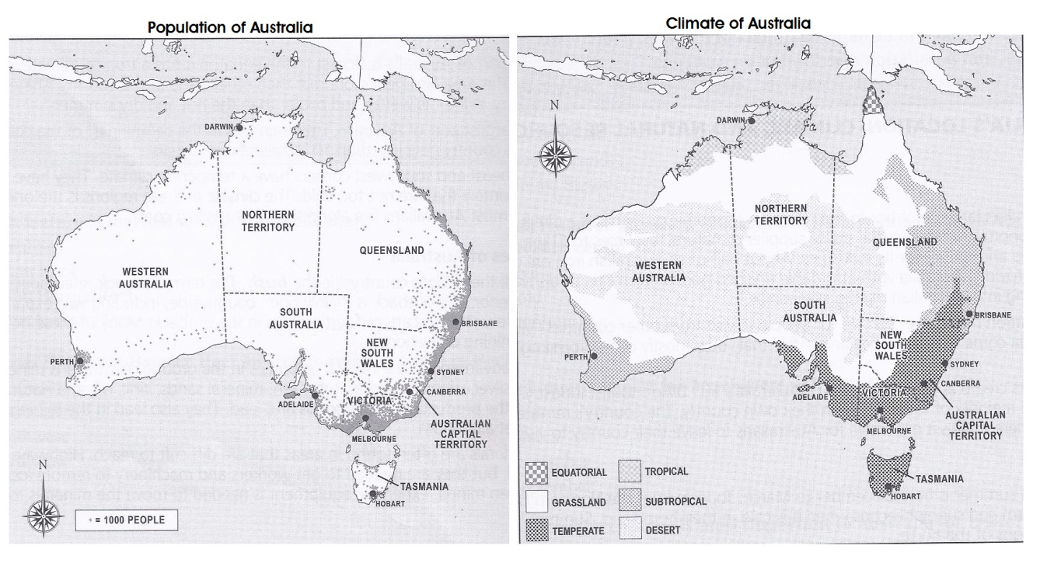
Use the maps above to answer questions 460-462.
- Where is the largest concentration of people on Australia? ____________________________
- Where is the coolest climate in Australia? _________________________________________
- Which city has the warmest climate? _____________________________________________
b. Describe how Australia’s location, climate, and natural resources impact trade.
- Which nation’s citizens visit Australia more than any other? ___________________________
- Which resource attracted thousands of immigrants to South Australia in the nineteenth century? _____________________________________________________________________
- Which month is best for beachgoer in Sydney? _____________________________________
- Which nearby country is most important to Australia for trade? ________________________
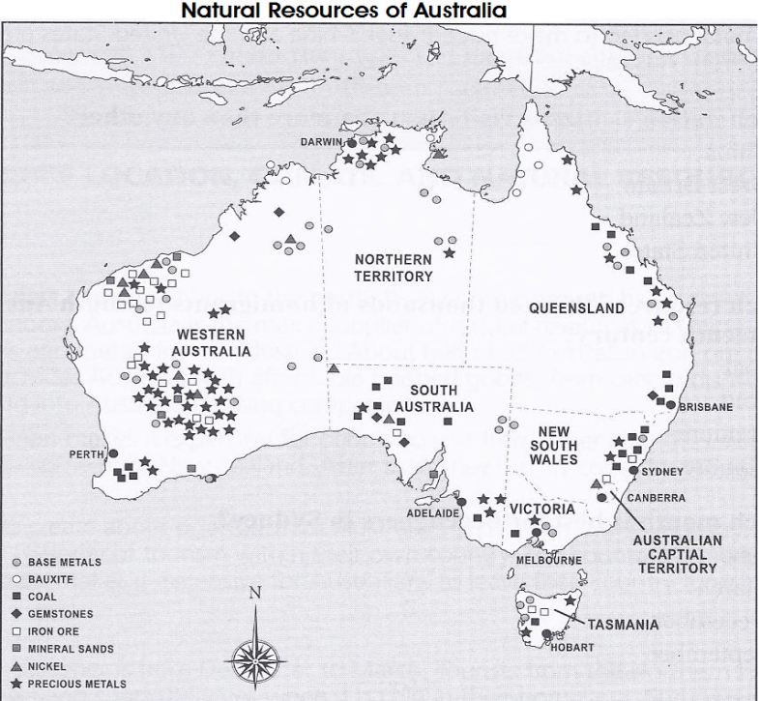
Use the map to answer questions 467-468.
- Which Australian state has the highest concentration of precious metals? ____________________
- What part of Australia has the lease amount of mineral resources? _________________________

Use the graph to answer the next three questions.
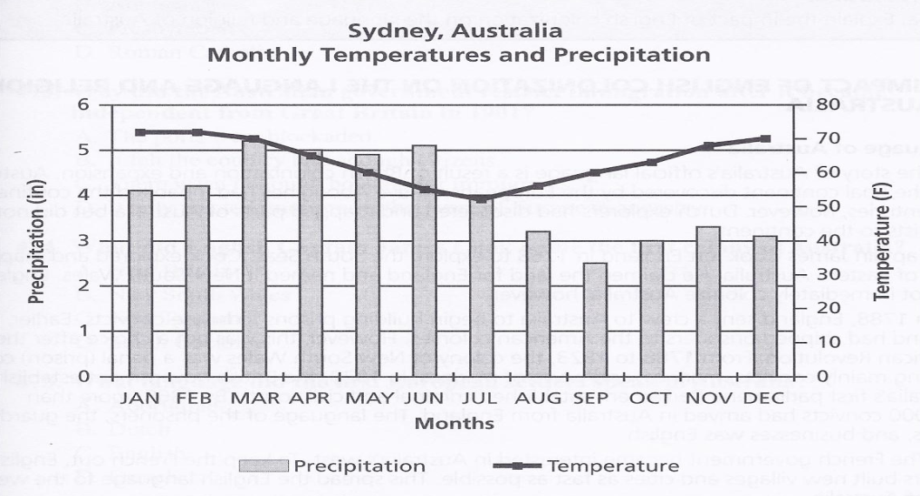
- Which is the warmest month? ______________________________________________________
- In which month does Sydney get less than 2 inches of rain? ______________________________
- Identify a statement that is true about Sydney __________________________________________
____________________________________________________________________________________
____________________________________________________________________________________

SS6G14: The student will describe the cultural characteristics of people who live in Australia.
a. Explain the impact of English colonization on the language and religion of Australia.
- What religion did most of the Australia’s Irish prisoners practice? ____________________
- Why did the Australian government restrict immigration after it became independent from Great Britain in 1901? __________________________________________________________
____________________________________________________________________________
- What did English Captain James Cook name the first colony of Australia? _______________
- What language did the first European settlers speak in Australia? _______________________
SS6G14 The student will describe the cultural characteristics of people who live in Australia.
b. Evaluate how literacy rate affects the standard of living.

- Identify an effect of low literacy rate? _________________________________________________
_________________________________________________________________________________
_________________________________________________________________________________
- Which is true of the literacy rate of in Australia? ________________________________________
_________________________________________________________________________________
_________________________________________________________________________________
- Which is true about Australia’s standard of living? _______________________________________
________________________________________________________________________________
________________________________________________________________________________
SS6G6 The student will compare and contrast various forms of government.
a. Describe the ways government systems distribute power: unitary, confederation, and federal
- Which is true of a confederate government? ____________________________________________
_________________________________________________________________________________
_________________________________________________________________________________
- Which describes the government of Australia? __________________________________________
_________________________________________________________________________________
_________________________________________________________________________________
- Give an example of a confederation. __________________________________________________
_________________________________________________________________________________
- In what government type is power split between a central government and the states?
________________________________________________________________________________

SS6G6 The student will compare and contrast various forms of government.
b. Explain how governments determine citizen participation; autocratic, oligarchic, and democratic.
- Which gives the people the most voice in making laws? __________________________________
________________________________________________________________________________
- In which form of government might a military dictator hold the power? ______________________
- Which statement BEST describes an oligarchy? _________________________________________
SS6CG6 The student will compare and contrast various forms of government.
c. Describe the two predominant forms of democratic governments; parliamentary and presidential.
- Who represents the queen in Australia’s government? ____________________________________
- Who has the most political power in the Australian government? ___________________________
- Which branch of government makes laws in Australia? ___________________________________
SS6CG7 the student will explain the structure of the national government of Australia.
a. Describe the federal parliamentary democracy of Australia, distinguishing form of leadership, type of legislature, and the role of the citizen in terms of voting and personal freedoms.

- What responsibility do Australians have after their 18th birthday? ___________________________
- Which official do citizens of Australia vote into office? ___________________________________
- What do the following phrases explain? _______________________________________________
- Signs bills into law
- Is commander-in chief of the military
- Acts a head of state for Australia
- Approves elections

- In which branch of government is the governor-general? __________________________________
- What are the three parts of the Australian Parliament? ____________________________________
______________________________________________________________________________________
- Which has the most power in the Australian government? _________________________________
- Who administers laws made by the Commonwealth Parliament in Australia? __________________

SS6E8 The student will analyze different economic systems.
a. Compare how traditional, command, and market, economies answer the economic questions of 1 -what to produce, 2-how to produce, and 3-for whom to produce.

- In Australia, who decides which goods will be produced and sold? _________________________
- What type of economic system was used by the Aborigines? _______________________________

SS6E8 The student will analyze different economic systems.
b. Explain how most countries have a mixed economy located on a continuum between pure and market and pure command.

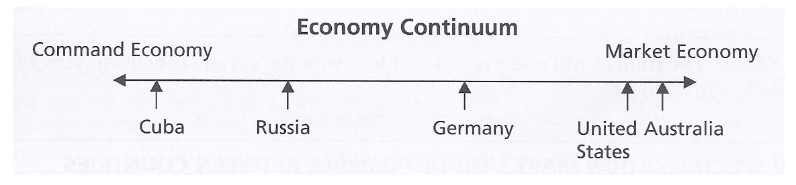
- Which country shown on the continuum has the freest economy? ___________________________
- Because most economies have characteristics of the command and market economy, we say they are _______________________________________________________________________________.

SS6E8 The student will analyze different economic systems.
c. Describe the economic system used in Australia.

- What protects businesses and consumers well on Australia? ________________________________
- Who sets the price for goods in Australia? ______________________________________________

SS6E9 The student will give examples of how voluntary trade benefits buyers and sellers in Australia. a Explain how specialization makes trade possible between countries.

- Give an example of specialization. ___________________________________________________
____________________________________________________________________________________________________________________________________________________________________
- Why do businesses specialize? _______________________________________________________
__________________________________________________________________________________
__________________________________________________________________________________
SS6E9 The student will give examples of how voluntary trade benefits buyers and
sellers in Australia.
b. Compare and contrast different types of trade barriers, such as tariffs, quotas and embargos.
- What actions did Australia take to try to stop fighting in Yugoslavia? ________________________
__________________________________________________________________________________
__________________________________________________________________________________
- Why are tariffs low in Australia? _____________________________________________________
__________________________________________________________________________________
SS6E9 The student will give examples of how voluntary trade benefits buyers and sellers in Australia. c. Explain why international trade requires a system for exchanging

- What is the currency used by people in Australia? _______________________________________
- Why do people have to exchange currency? ____________________________________________
__________________________________________________________________________________

SS6E10 The student will describe factors that influence economic growth and examine their presence or absence in Australia.
a. Explain the relationship between investment in human capital(education and training and gross domestic product.
b. Explain the relationship between investment in capital (factories, machinery, and technology) and gross domestic product (GDP).
c. Describe the role of natural resources in s country’s economy.
d. Describe the role of entrepreneurship.

- Give examples of investment in human capital. ________________________________________
- What has helped in Australia to have a high GDP? ______________________________________
- What is an example of investing in physical capital by a company? __________________________
__________________________________________________________________________________
- What has been one result of Australia’s investment in capital? _____________________________
__________________________________________________________________________________
- Give an example of a natural resource._________________________________________________
- What natural resource helps Australia trade with other countries? ___________________________
- What is one reason that Entrepreneurs are good for Australia? ______________________________
__________________________________________________________________________________
- What is one reason entrepreneurs like Australia? ________________________________________
__________________________________________________________________________________

SS6H8 The student will describe the culture and development of Australia prior to contact with Europeans.
a. Describe the origins and culture of the Aborigines.

- From where did the Aborigines enter the Australian continent thousands of years ago? __________
__________________________________________________________________________________
- What weapons did the Aborigines invent? ____________________________________________
- Which social group of the Aborigines was made of 10 to 20 people? _________________________
- The Aborigines were _____________________________________________________________.

SS6H9 The student will explain the impact European exploration and colonization had on Australia.
a. Explain the reasons for British colonization of Australia; include the use of prisoners as colonists.
- The prisoners used to colonize Australia in the late 1700s were primarily from which country? _______________________________________________________________________________
- Which war made the government of Great Britain look to Australia as a penal colony? ________________________________________________________________________________
- What part of the first prisoners sent to Australia were women? _____________________________
- What was the original name Captain James Cook gave to the colony of Australia? ______________

SS6H9 The student will explain the impact European exploration and colonization had on Australia.
b. Explain the impact of European colonization of Australia in terms of diseases and weapons on the indigenous peoples of Australia.

- What was the greatest threat to the Aborigines after the Europeans began settling Australia?
_________________________________________________________________________________
_________________________________________________________________________________
- What event in the mid-19th century led to the killing of hundreds of Aborigines? _______________
__________________________________________________________________________________
- What was an effect of British settlement of Australia? ____________________________________
______________________________________________________________________________________
______________________________________________________________________________________

