Dear Parents,

This year your student will be required to create a Social Studies Fair Project.
Directions are included in this packet along with a timeline of assignments.

Please fill out the first two pages and send back to your child’s teacher.
Students may partner together (groups of 2 or 3 only) to complete the project. If your student wishes to do this, let his/her teacher know and she will send a team contract that each person must sign.

We will have a school fair on January 11, 2017, and if your student places first, he/she will go on to the district fair.
If we can be of any assistance please let us know.

Thank you for supporting your child’s learning,
The 6th Grade Team ☺
Social Studies Fair Project Timeline
All of these assignments will total 6 grades for Social Studies. If a student fails to turn in an assignment, they will receive a zero. The completed project will be a test grade.

Assignment 1: Think about possible project ideas using history (using the past to help understand the present and the future) or economics (people as consumers of goods and producers of services) as your category. Get your topic approved by your teacher. Due date: November 30, 2017.
Assignment 2: Develop a title and a question based on your topic. Ask your parents to help you formulate 2 research questions that are relevant to your topic. Get one question approved by your teacher. Determine the purpose for choosing the topic and question. Write a paragraph explaining why. Due date: December 6, 2017.
Assignment 3: Choose at least 3 methods in which you will complete your research (online, books, newspapers, magazines, surveys, movies, etc.) Due date: December 13, 2017.
Assignment 4: Conduct your research. Keep a daily log of your progress. Summarize the data. Summary due date: January 4, 2018.
Assignment 5: Conclusion-answer the question based on the data collected during your research. Due date: January 7, 2018.

Assignment 6: Final project with presentation board. Due date: January 11, 2017.
Please cut here. Keep the top portion for your records-------------------------------------------------------
(Please initial and sign below, return to your teacher by November 30, 2017)
- I acknowledge that I have received this packet that details the requirements of my child’s social studies fair project.
- I am aware that this project is required and will result in a test grade for writing and social studies.
Student:__________________
Parent Signature:_____________________________________Date:______________

Social Studies Fair Topic Ideas
If you have an idea that is developed from these questions or from a current event, please submit for approval?
- How have the 13th, 14th, and 15th amendments of the Civil War affected people’s rights today?
- How has Brown vs. the Board of Education affected schools today?
- How has the invention of the automobile effected culture today?
- What was the Emancipation Proclamation’s roll in the abolition of slavery in America?
- How did the United States interest in the Panama Canal affect trade?
- How has communication affected history? (Inventions)
- Why were the Ironclads significant in the Civil War?
- What was the Significance of the Gettysburg Address?
- How has the education of women affected American history during the 20th/21st centuries?
- What is the correlation between Civil Rights Act of 1954 and the achievements of African Americans?
- What is the correlation between Civil Rights Victories and the assassination of Martin Luther King?
- What president has contributed the most to the establishment and protection of the rights of Americans?
- Why did Truman choose to bomb instead of invade?
- How did the Island Hopping war strategy help to advance the allies during World War II?
- How has propaganda changed the views of Americans? Does it change American views today?
- How are our three branches of government (“checks and balances”) significant as United States prospers and grows in population?
Please cut here. Keep the top portion for your records-----------------------------------------------------------
Due: November 30, 2017
Name:____________________________________ Date:____________________________________
My project Idea:
__________________________________________________________________________________________________________________________________________________________________________________________________________________________________________
Due: December 6, 2017
The Question I’m going to answer using research:
__________________________________________________________________________________________________________________________________________________________________________________________________________________________________________
My purpose for choosing this topic is:
Titles of Winning Projects from State Fairs
“Social Security: Are Educators and Others Prepared to Fund Their Retirement?”
“I Am Homeless: Where Can I Get Help?”
“Are You Ready?”
“Citizenship – Can You Pass the Test?”
“Pricing Trends in the Retail Market”
“What is Ramadan? What Happens in Ramadan and Why?”
“What is Coca-Cola’s History and Economic Impact on Georgia?”
“Protected Species of the Okefenokee Swamp”
“Red, White, and Black Civil War Signals”
“What Did the Hookworm Eradication Program Accomplish Regarding Public Health in the South?
“How Did Sociopolitical Conditions in the Second Half of the Twentieth Century Affect Music?”
“The Soul of the Samurai”
“Teenage Spending”
“Venice, Italy, vs. the Adriatic Sea”
“The Mongols: Civilized or Savage?”
“The New Deal”
“Why Are There So Many Chinese Girls Who Need to Be Adopted?
“Upgrading Our Future: Are We Technology Dependent?”
“How Can Atlanta Survive Delta’s Failure?”
“What Damage, if any, Is Human Interaction Doing to the Great Barrier Reef?”
“How Did Eleanor Roosevelt Become Known as ‘First Lady of the World’?”
“50 Years After Brown v. Board of Education: Are Our Schools Desegregated?”
29
“Was the South Justified in Seceding from the Union?”
“How Did Voting Units Affect the 2004 Presidential Elections?”
“Should Auto Insurance for Teen Boys Be More Expensive Than for Teen Girls?”
“NASA Technology – Down to Earth”
“Can Public Schools Offer Fast Food as a Healthy Alternative Lunch?”
“Pet Therapy”
“What Are the Origins of Currency?”
“How Do Storm Chasers Help Save Lives?”
“Andersonville: The Worst Civil War Prison”
“The Pledge of Allegiance – How Do You Feel?”
“How is Title IX Funding Affecting Men’s and Women’s Sports?”
“What Events Led to Jimmy Carter Winning the Nobel Peace Prize?”
“Origins of Mummification”
“Common Cents: Should the Penny Go?”
“How Many People Can Identify the Continents?”
“What is the True Story Behind the Life and Talents of Blind Tom?”
“How did ‘Black May’ of 1992 Directly Impact the Politics in Thailand?”
“West Nile Virus”
“The Retail Industry: Friend or Foe During the Time of Economic Slowing?”
“Mardi Gras”
“How Successful Have the Land Reform Programs Been in Zimbabwe?”
“World War III: Africa vs. AIDS”
“Magic, Religion and Science”
“Returned with Honor – POWs”
“The Plight of Sudanese Refugees in Atlanta”
Guidelines for Students: Selecting a Topic
(Adapted from DeKalb County Elementary Social Studies Fair Handbook)

1. Avoid topics that are limited.
Example: What crops are grown in our county?
A student cannot write a report on a topic that can be explained in a few words or a sentence.
Better topic: What is the economic impact of peanut production in our county?
2. Avoid topics that are too broad.
Example: What happened during the Civil War?
Topics which are too big make it impossible to find all the information that is needed to cover the topic adequately.
Better Topic: The Role of (name of a local historical figure, place or event) in the Civil War
3. Some topics have no available information.
Example: Why did Henry Hudson get into trouble with the crew of his ship?
We often do not know exactly why people did what they did in the past.
4. Avoid topics that are confusing because it cannot be determined what specific information is being explored.
Example: What do people of Japan like?
We know that the people of Japan may differ in their likes and dislikes.
Better topic: A Comparison of Japanese women and American women in sports competition
5. Avoid topics on which people throughout the world cannot agree.
Example: What is the most powerful country in the world?
The topic should be supported with facts. The facts are used to arrive at a conclusion.
Better topic: Why might Japan be considered one of the strongest economic powers in the world?
6. Research the topic from a social studies viewpoint rather than investigating it as a natural science topic.
Example: Nuclear power as a political issue rather than "how it works"
Social Studies Research
Preparing Student Projects
(from the teaching archives of Dr. Glen Blankenship)

I. CHOOSE A TOPIC.
A. Social Studies Disciplines
1. ATHROPOLOGY – People are survivors. I am a survivor.
2. ECONOMICS – People are consumers and producers. I am a consumer and producer.
3. GEOGRAPHY – People are earth dwellers. I am an earth dweller.
4. HISTORY – People are descendants. I am a descendant.
5. POLITICAL SCIENCE – People are citizens. I am a citizen.
6. SOCIOLOGY/SOCIAL PSYCHOLOGY – People are members of groups. I am a member of many groups. – People are individuals. I am an individual.
[Ann Angell, Emory University]

B. Think of a current topic about which you like to read and study; think of problems you would like to see solved.

C. Look through newspapers, a variety of magazines (Time, Newsweek, U.S. News and World Report, Psychology Today, National Geographic, etc.) and other current publications. Read current editorials, listen to radio and television news broadcasts.

D. Brainstorm possible topics. Talk to parents, teachers, and other students about topics that may interest you.

E. Identify any bias you may have concerning a possible topic. Determine if you can sort through the data and not be prejudiced.

II. FORMULATE AN APPROPRIATE RESEARCH QUESTION.
- List ten questions that deal with your topic.

B. Ask each of these questions about your possible research questions:
1. Can you do original research on the topic? (preferable)
2. Is the topic relevant? Will the answer be of any benefit to you or your community?
Ask “so what?” about the question.
3. Does the question use words that need to be defined?
4. Did you avoid questions with “yes” or “no” answers?
5. Do you already know the answer to the question? (avoid)
6. Are you biased or prejudiced about the topic?
7. Will you be able to draw some kind of conclusion to the question?
8. Can you find information in your community on the topic?

C. Narrow your list of questions to three.
1. Discuss the questions with parents, teachers, and friends.
2. Choose the best research question.
Social Studies Research
Preparing Student Projects
(Continued)

III. DETERMINE THE PURPOSE FOR CHOOSING THE TOPIC AND QUESTION.

A. Why have you chosen this topic?
B. Write a paragraph explaining why.

IV. CHOOSE METHODS OF RESEARCH.

A. Begin in the Media Center.
1. Books
2. Magazines (use the Reader’s Guide)
3. Newspapers (scan indices for the past several years)
4. Government Documents
5. Vertical Files
B. Choose at least one (preferably 2 or 3) original means of research.
1. Interviews
2. Polls
3. Oral Histories
4. Case Studies
5. Questionnaires
6. Photographs
7. Movies/Sound Recordings
8. Experiments/Observations
9. Maps
10. Physical Remains (buildings, artifacts, landscapes)
11. Unpublished Manuscripts (wills, letters, deeds, minutes, diaries, family Bible)

V. CONDUCT THE RESEARCH.
A. Devise a timeline.
B. Keep a daily journal of the progress (both successes and setbacks) of the progress of your research.
C. Roadblocks may occur during the research process. When they happen, do not quit. Talk with your parents/teacher and revise the plan. Not finding an answer may be just as significant as finding one.

VI. SUMMARIZE THE DATA.
A. Outlines/Essays
B. Statistics (in the form of graphs, tables, etc.)
C. Photography/Diagrams/Drawings

VII. DRAW A CONCLUSION.
A. Answer the question using the data collected during the research. The project is of no use if you do not answer the question.
B. Use decision-making charts to help you draw a conclusion.

VIII. DETERMINE A PRESENTATION FORMAT
A. Select a format (visual, written, dramatic presentation, audio, etc.)
B. Use charts, graphs, photographs, drawings, maps, artifacts, diagrams, films, diagrams, political cartoons, murals, recordings slides, videotapes, computers, etc.

List of Social Studies Sources/Resources/Tools
Gathering information concerning one project may require distribution of questionnaires to a sample of people and tabulation of the results; another project may be based on the study of newspapers; and still another project may be based on studying the government publications. The following are sources of information.
- Newspapers, magazines, published letters, memos
- Unpublished manuscripts (wills, letters, deeds, church minutes, diaries)
- Government publications (international, national, state and local)
- Publications by private agencies
- Physical remains (buildings, battle areas, artifacts)
- Oral interviews, polls and questionnaires, photographs, sound recordings, and films
- Internet web sites
As a rule, a good researcher uses a variety of these sources of information. Successful past projects have utilized as many of these tools as were appropriate to the subject researched.
- Case studies
- Experiments
- Observations
- Graphic studies
- Historical examinations
- Maps
- Samples
- Surveys
- Statistical analysis
- Interviews
The use of materials such as toy dolls, plastic models, and commercial products for illustration is discouraged. Objects should be made by the student and not purchased. Building materials such as wood, modeling clay, pipe cleaners, and foam board may be purchased for use in constructing models. The following are suggested as ideas for illustrating information and results in the visual display:
- Artifacts
- Charts and graphs
- Computers
Diagrams
- Photographs and illustrations
- Historical collections
- Maps
- Models
- Murals
- Recordings
- Power Point presentations (see regulations for length)
- Video

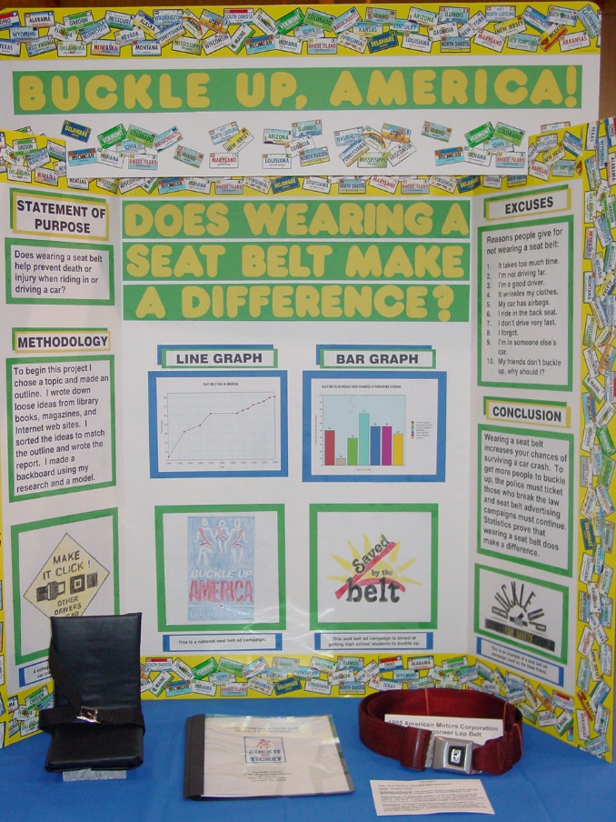
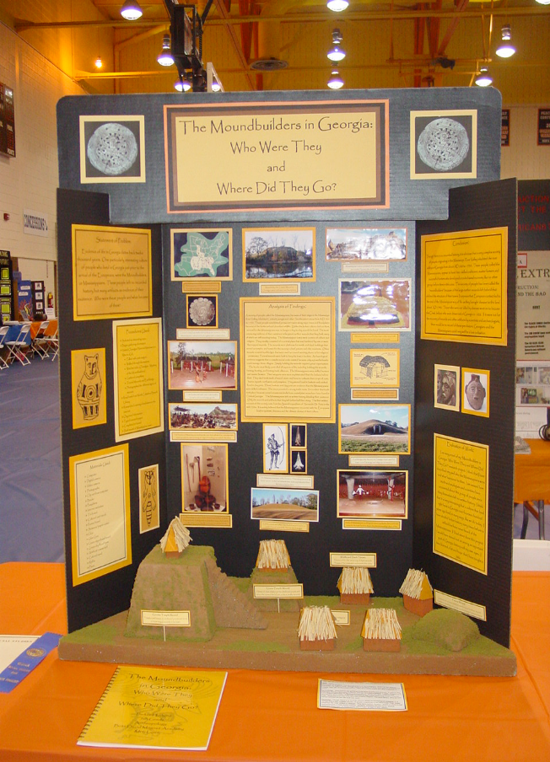
Here are some examples!

