Latin America History Test Study Guide
- Know that the Triangular Trade and the Columbian exchange were the same thing. Goods were being imported and exported from the America’s to Europe to Africa to the America’s.
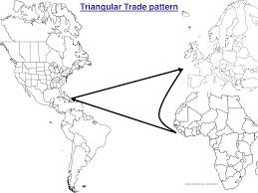
- Who was Pizarro?
- Who was Cortez?
- Who were the Zapatista’s? (Where are they located, when did they meet, and why are they important to history?)
- What was the Columbian Exchange? (When did it take place, where did it take place, why is it important to history?)
- Be able to compare and contrast Miguel Hidalgo, Simon Bolivar, and Tousaint L’Ouverture. Be able to tell what motivated them, were they successful in their lifetimes, and how did they impact history?
- Slave labor allowed the America’s economies to grow rapidly.
- Who was Simon Bolivar?
- The poor people supported the Cuban Revolution.
- Who was Atahualpa?
- Who was Montezuma II?
- Who was Miguel Hidalgo?
- Who was Toussaint L’Ouverture?
- Know that the destruction of the Aztec and Inca civilizations was a direct result of European exploration of the America’s.
- Descendants of African slave have kept their culture alive by passing on African traditions and customs to their descendants.
- Spain’s influence is still alive in Latin America though language, religion, and architecture.
- Be able to tell why conquistadors went exploring and why they were so successful at conquering such large empires.

