[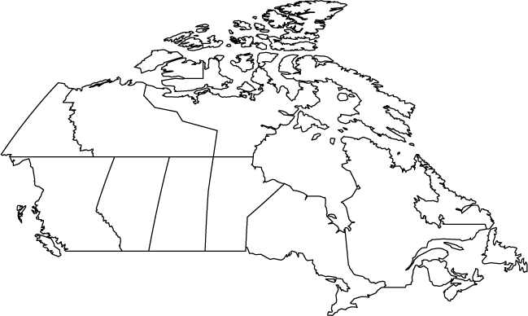](http://www.google.com/url?sa=i&rct=j&q=&esrc=s&frm=1&source=images&cd=&cad=rja&docid=w5_2wdY2zhQsfM&tbnid=rNBc-DUaAevF2M:&ved=0CAUQjRw&url=http://www.worldatlas.com/webimage/countrys/namerica/caoutl.htm&ei=NzaKUobgO42ukAei_IGQCQ&bvm=bv.56643336,d.eW0&psig=AFQjCNGGVtdB1JEvz4YDBoNjramQlzsgSw&ust=1384875927228058)