Job Perspectives
Directions: Answer the questions below to help you get in to the mindset of your job. Be sure to look that the Canadian Standards through the eyes of this job because these are real Canadian citizens’ lives, and we want them to be represented. Use complete sentences.
Rubric: 3 pts each- Does it reflect perspective? Is it a sentence? Is it accurate? Total: /18
- When should people use natural resources to make money?

- How could the education system of Canada best equip you to do your job?

- Why is having a federal government good for you?

- What is your role in the government?

- How do you feel about Canada’s independence?

- What language(s) would you most likely speak?
Job title:
Name:

Job description in two sentences:

Directions: Locate and color all of the locations on the Physical and Political Maps of Canada that are found in the key. Be sure to find all of the locations in the key and appropriately color them on the maps. Also give each map a title and a compass rose.
Physical and Political Map Rubric:
_____ 2 Map Titles and a Compass Rose (3 pts)
______ 7 Physical Features Colored in the Key and Map (7 pts)
______ 10 Provinces, 3 Territories, Capital Colored in the Key and Map (14 pts)
______ Your location based off of your job Labeled on the Keys and Maps (2 pts)
______Neatness and Accuracy (4 pts) Total /30

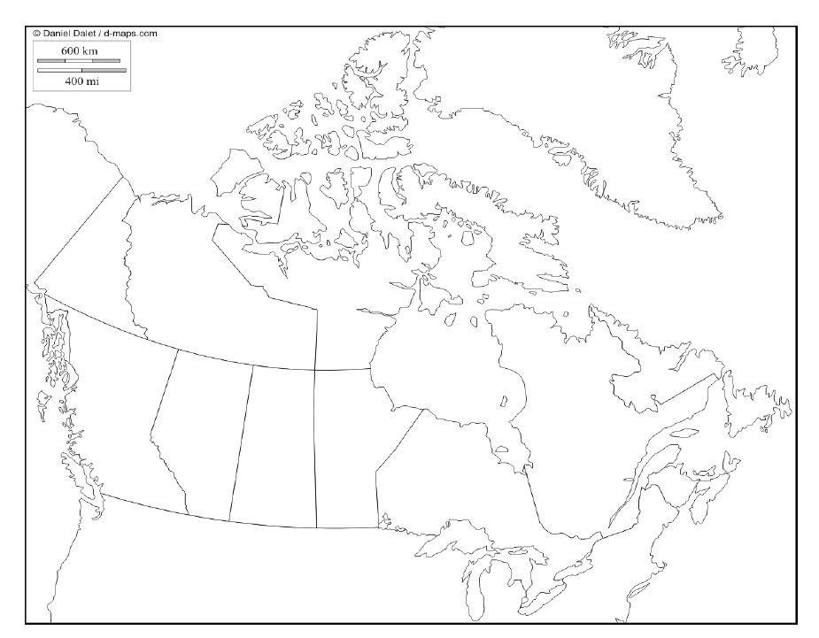
Map Title: Compass:
Map Key
Your Job’s Location(s)
______ Ottawa
______ British Columbia
______Saskatchewan
______ Yukon Territory
______ Nunavut
______ Northwest Territory
______ Alberta
______ Quebec
______ Ontario
______ Newfoundland and
Labrador
______ Prince Edward Island
______ New Brunswick
______ Nova Scotia
______ 2 United States Sides
______ Greenland

Map Title: Compass:
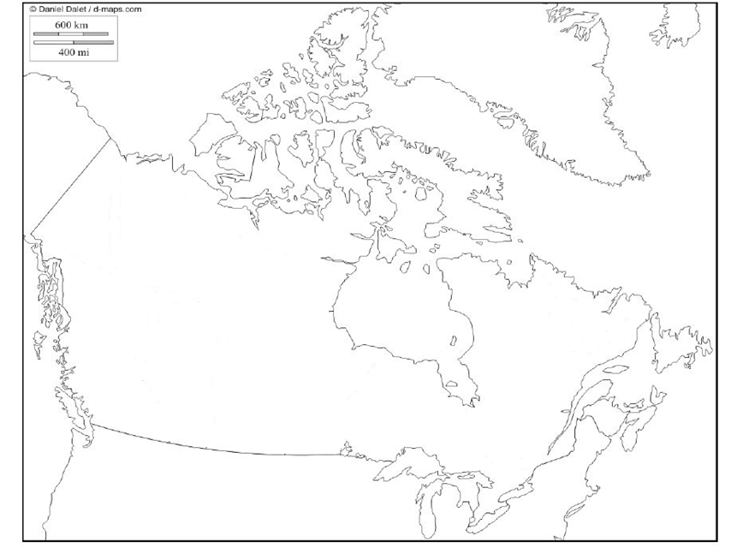
Map Key
Your Job’s Location(s)
______ Canadian Shield
______ Rocky Mountains
______ Great Lakes
______ St. Lawrence River (Sea Way)
______ Hudson Bay
______ Pacific Ocean
______ Atlantic Ocean
______ Arctic Ocean

,

Directions: Using your political and physical maps, choose a province in the region where you have already indicated your job would most likely be. You will write a persuasive letter to a friend who lives in a province in a totally different region of Canada, convincing them to relocate to your province. Be sure to compare the climate, natural resources and locations of the two provinces. Remember, you are trying to persuade them. So use logos (logic and facts from your charts you worked on), pathos (emotions), and/or ethos (why it’s the right thing to do).

Environmental Issues Identifications
,
Directions: Use the CRCT Pages (p. 47-52) and the Canadian Environmental Issues PPT on the website to create general identifications. Match one of the following topics with the pictures that best represent the environmental issue: Clear Cutting, Extraction of the Canadian Shield, Acid Rain, and Pollution of the Great Lakes. Answer what is it, where is it found in Canada, when does it occur, and why is it significant (effects)
Environmental Issue Title:

What is it? When did/does it occur?

Where is its location in Canada? Why is it historically significant (effects)?

Environmental Issue Title:

What is it? When did/does it occur?

Where is its location in Canada? Why is it historically significant (effects)?

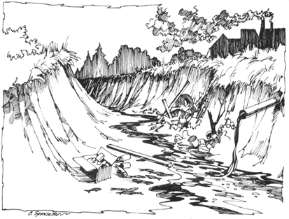
Environmental Issue Title:

What is it? When did/does it occur?

Where is its location in Canada? Why is it historically significant (effects)?

Environmental Issue Title:

What is it? When did/does it occur?

Where is its location in Canada? Why is it historically significant (effects)?

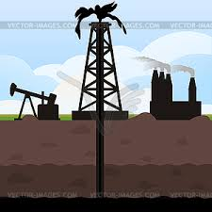
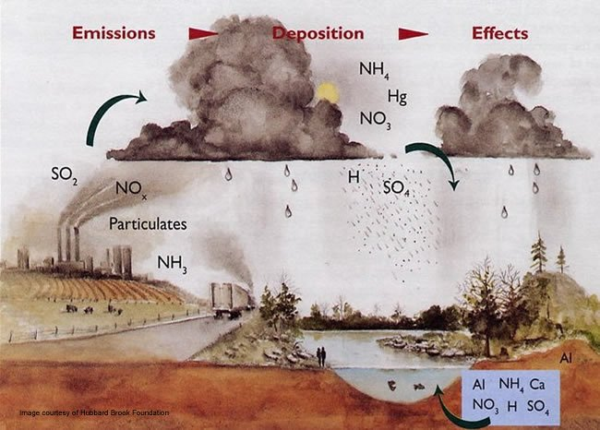
Directions: Use a Word Document, Pic Collage, or this paper to create a flyer about the use of natural resources from the perspective of your job. If natural resources are necessary for your job, then you will want to create the poster explaining why the natural resources are needed and environmental issues are a necessary evil. Alternatively, if your job is against natural resource use and for protecting the environment, create a flyer for this need. You must use at least 2 of the environmental issues for Canada.

Directions: Get ready for the Canadian Environmental Issues Debate! Once you have received your assigned topics, use the links provided in class to research the advantages, disadvantages, and solutions of using Canada’s natural resources. The other topics, you will need to take notes on during the debate. A collection of these notes will also be found online… more details to come in case you miss something.
Solutions:

Solutions:

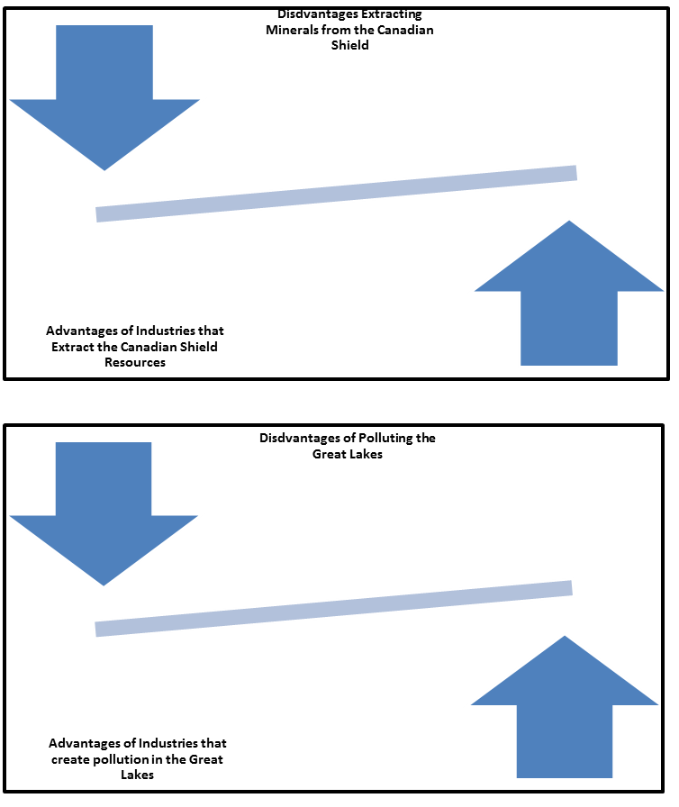

Directions: Get ready for the Canadian Environmental Issues Debate! Once you have received your assigned topics, use the links provided in class to research the advantages, disadvantages, and solutions of using Canada’s natural resources. The other topics, you will need to take notes on during the debate. A collection of these notes will also be found online… more details to come in case you miss something.
Solutions:

Solutions:

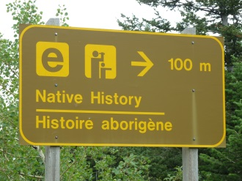
A Bilingual Country
Sign Example:
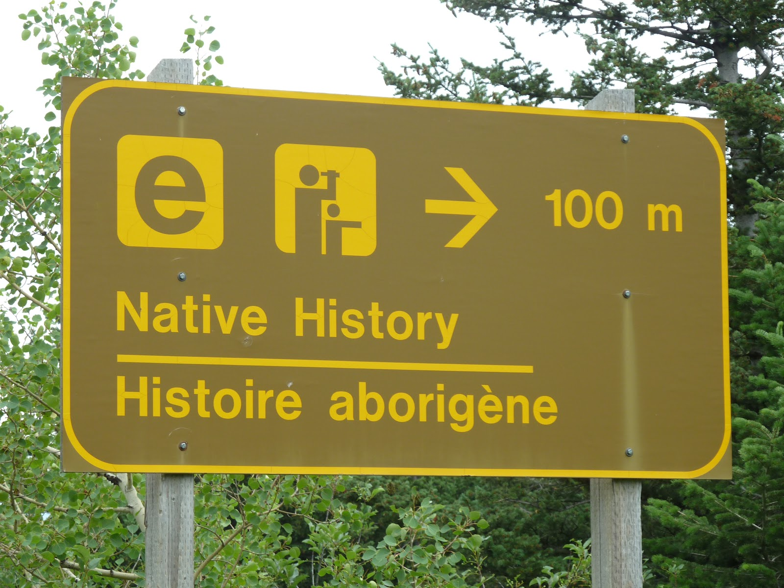
Map Title:
_________________
Map Key
____ English Speaking
____ French Speaking

Sign 1:

Sign 3:

Sign 2:

Directions: Create a Map Key for provinces and territories whose citizens mainly speak French vs English, then color the map accordingly.
Then draw 3 different signs that would be found along the road in Canada. Remember the signs will need to have the words in 2 different languages. One example is provided for you.
Finally, answer the questions from your job’s perspective with complete sentences.
Rubric: _______ 3 signs (6 pts) _____ Map Key (2 pts)
______ Map (2 pts) _____ Questions (14 pts)

Canadian Language Questions (Answer from your job’s perspective):
1. How does the language you speak compare to the rest of Canada’s language? Is it the same or different? Justify your answer.

2. Which language/languages would you most likely learn in school? Justify your answer.

3. How have the French and English cultures influenced Canada? Justify your answer.

